Module 6 Project: Optimization.

Dhairyav Jatin Shah

College of Professional Studies, Northeastern University

Professor: Zhi(Richard) He

April 1, 2023

**Introduction**

The given data includes several scenarios and problems from real life that call for analysis and decision-making in order to achieve the best results. In the first instance, Chimotoxic, a business that produces dangerous chemicals, and Allen, a manager at Rockhill Shipping & Transport Company, are negotiating a trash transportation contract. The difficult part is guaranteeing safe and legal transportation of garbage from six plants to three disposal sites while minimizing shipping expenses. Direct shipping or transshipment are two choices that should be carefully considered in terms of costs and travel distances. In the second case, an investor has chosen a portfolio of assets that consists of gold, put options, high-tech companies, foreign equities, energy stocks, and CDs. Based on historical data, an estimate of the predicted return for each asset class has been made. To identify the risk attached to each asset and the total risk of the portfolio, the investor needs to analyze the covariance matrix of the asset returns. With this knowledge, the investor can modify the weightings of each asset class to improve the performance of the portfolio.

**Analysis**

**Part 1 :**

We have calculated the cost of shipping a barrel of garbage from each of the six factories to each of the three disposal sites in order to determine whether our approach is feasible. Table 1 displays the shipping costs. Also, as shown in Table 2, different amounts of waste products are produced by the plants every week. A maximum of 75, 85, and 90 barrels per week can be accommodated at each of the three trash disposal facilities in Orangeburg, Florence, and Macon.

|  |  |  |  |  |  |  |
| --- | --- | --- | --- | --- | --- | --- |
| ***Table 1: Shipping costs, per barrel of waste from six plants to three waste disposal sites*** | | | |  | ***Table 2: Amount of Waste generated by each plant*** | |
|  |
| ***Plant:*** | ***Orangeburg*** | ***Florence*** | ***Macon*** |  | ***Plant:*** | ***Waste per Week (bbl)*** |
| ***Denver*** | **$ 10** | **$ 8** | **$ 9** |  | ***Denver*** | **45** |
| ***Morganton*** | **$ 14** | **$ 10** | **$ 8** |  | ***Morganton*** | **35** |
| ***Morrisville*** | **$ 13** | **$ 18** | **$ 11** |  | ***Morrisville*** | **55** |
| ***Pineville*** | **$ 15** | **$ 11** | **$ 12** |  | ***Pineville*** | **50** |
| ***Rockhill*** | **$ 9** | **$ 12** | **$ 9** |  | ***Rockhill*** | **30** |
| ***Statesville*** | **$ 18** | **$ 12** | **$ 13** |  | ***Statesville*** | **35** |

We must determine the total amount of waste that can be transported to each of the three waste disposal facilities while accounting for shipping expenses and site-specific capacity restrictions to move forward with the discussions. Using linear programming, a mathematical optimization technique that can be used to discover the best solution to a problem given a set of constraints, is one potential answer to this challenge. Given the limitations on the amount of waste that may be delivered to each disposal site, we can construct a linear programming model that minimizes the overall shipping cost.

Decision variables Xij can be created to indicate the volume of garbage moved from plant i to disposal site j. The total shipping cost is the objective function that needs be minimized:

With respect to the following Constraints:

 Each garbage disposal site's capacity restrictions are shown by the first three constraints. The following six restrictions guarantee that each plant's whole amount of garbage gets transported. The last restriction guarantees that the decision variables are not negative. To find the optimal solution which will provide the minimum required shipping cost we will be using MS EXCEL. The output from the given process is given below.

As we can see from the above outcome, our total minimum cost is **$2575.00** .

We need to consider a scenario where we can ship the waste using the transshipment approach. In this case, transshipment is necessary to provide for the possibility of using intermediary shipping points to move trash from the plants to the disposal locations. RSTC may be able to lower transportation expenses by utilizing more cost-effective shipping routes by dropping and picking up loads at intermediary locations. Also, it gives the transportation network greater flexibility because RSTC may combine multiple shipping routes to convey the garbage based on the number of trucks available, the state of the roads, and other elements that can affect shipping costs.

Next, to calculate the shipping cost where the plants and the disposal sites are used as intermediate shipping points. Table 3 shows the estimate of shipping cost per barrel between the six plants as well as the 3 disposal plants.



After using solver, we can see that when the plants and disposal sites are used as intermediate points for shipping our shipping cost drops to **$2460.00** as shown in the image below.



We can see that after using the solver the total minimum shipping cost has been reduced to $2460.00. Therefore, we can say that using transshipment would be feasible in this scenario as the shipping cost comes down by **$115.00**.

In the next step, if the waste disposal company agrees to increase the capacity of each of the three waste disposal facilities by 5 barrels per week – Orangeburg(80), Florence(90), and Macon(95) – we must evaluate how this adjustment would affect the shipping costs under both direct shipping and transshipment scenarios. We can do this using the sensitivity report derived from the excel solver for both the cases.

Considering the direct shipment scenario. A snapshot of the sensitivity report is attached below,



From the obtained sensitivity report we can see that the allowable increase for the Orangeburg Disposal Site is very small ( 1*e30), and the shadow price obtained is 0. Hence increasing the capacity of Orangeburg Disposal Site from 75 to 80 bbp per week will not affect the shipping cost, whereas we can see that for the other 2 sites i.e., Florence and Macon Disposal Sites the allowable increase is 45 and 35 bbp week, and the shadow price is obtained as -2 and -1 respectively. This states that for an increase of 1 bbp per week there will be a decrease of $2 for Florence and $1 for Macon. Hence, if we increase the capacity of the Florence and Macon Disposal Sites to 90 and 95 respectively there will be a reduction of $15 in the total shipping cost. Hence the total minimum shipping cost now will be **$2560**. Since there is an increase in the capacity of the waste there is a decrease in the shipping cost per week.

The same can be observed for the scenario of transshipment as well. A snapshot of the sensitivity report from the earlier transshipment is given below,



The transshipment case is also similar to the direct shipment, and we can see that the shadow price of Orangeburg is 0 and the allowable increase is also very small. Hence increasing the capacity of this site will not make in changes in the total minimum shipping cost. Whereas in the case of Florence and Macon we can see that the shadow price for both the sites is -1 and the allowable increase is obtained as 10. Therefore, increasing the capacity of both these sites will decrease the shipping cost by a total of $10. Therefore, the shipping cost will not be reduced from **$2460** to **$2450** by increasing the capacity of Florence and Macon to 90 and 95 bbp per week.

**Part 2**

The Markowitz Portfolio Theory (MPT) is a method frequently used in finance to decide how to allocate assets in a portfolio in order to reduce risk for a specific level of expected return. According to the theory's underlying tenet, risk-averse investors choose to maximize their return for a given level of risk or reduce risk for a given level of return.

In this scenario, the investor wants to deposit $250,000 into a portfolio made up of gold, put options, high-tech companies, overseas equities, energy stocks, and CDs. The assets' covariance matrix and expected return are provided. The challenge is to choose a portfolio allocation that minimizes risk and offers at least a 15% baseline expected return. We must determine the portfolio's expected return and variance in order to address this problem using MPT. The weighted average of the expected returns of a portfolio's various assets, where the weights represent the proportions of the investment in each asset, represents the portfolio's expected return. Like this, a portfolio's variance is the weighted average of the variances and covariances of its constituent assets.

Let the proportions of the investment in gold, CDs, foreign equities, energy stocks, high-tech stocks, and put options be x1, x2, x3, x4, x5, and x6, respectively. The portfolio's anticipated return is then determined by:

E(Rp) = X10.05 + X20.28 + X30.22 + X40.15 + X50.15 + X60.07

Use the covariance matrix to determine the portfolio's variance. The portfolio's variance can be stated as follows:

Variance of the portfolio = ∑(i=1 to n) ∑(j=1 to n) wij * wj * Covij

where n is the number of assets in the portfolio, wij is the weight of asset i, wj is the weight of asset j, and Covij is the covariance between assets i and j. The variance that we calculate will the be risk for the stock with respect to the individual stock’s anticipated return.

The goal is to reduce the portfolio's variation while keeping in mind that the projected return must be at least 15%. With the help of a solver, we can determine the following optimal weights for the portfolio's assets:



Therefore, the investor should allocate $20,825.93 to high tech stocks, $51,363.57 to foreign stocks, $37,318 to energy stocks, $61,707.10 to put options and $78,785.27 to gold to achieve the desired expected return of 15% with minimum risk. The obtained risk for the desired allocation is given below.



From the above given table, we can say that for a 15% return on investment the is 0.204 %.

For the next step, we will calculate the risk for the following values as the baseline return values. We will then plot e versus r (where r is on the x-axis). Where e is the expected return of the portfolio and r is the minimum risk for that return.



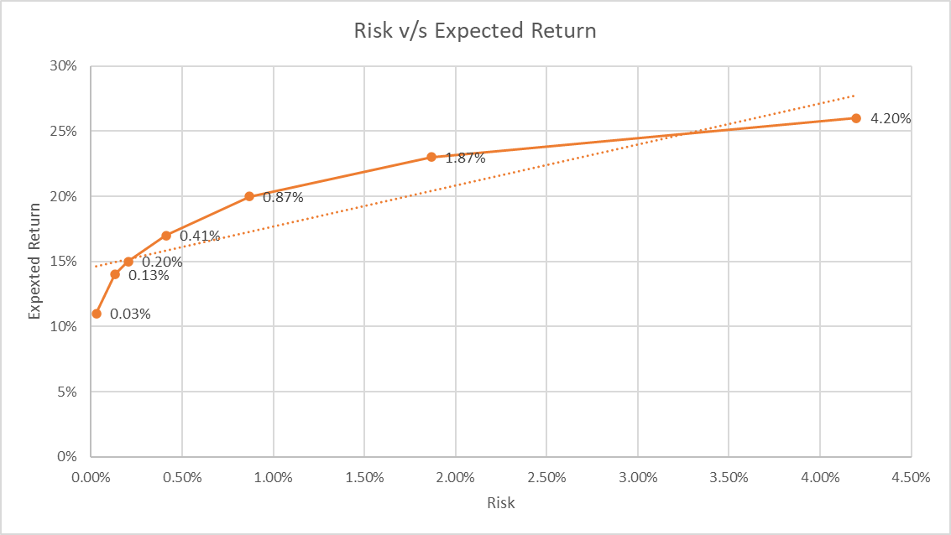The e versus r plot is given below.

The resulting pairs of solutions (r, e) can then be displayed on a graph with e on the y-axis and r on the x-axis. The efficient frontier is a curve that could be visible on the resulting plot. This curve indicates the set of portfolios that have the lowest risk for a given level of expected return. The efficient frontier may be concave in terms of the relationship between r and e, reflecting declining marginal returns to risk minimization. This indicates that the expected return may decline at a decreasing pace as we move along the efficient frontier to the left (lower risk). This association exists because there is a trade-off between risk and reward in investing: bigger gains typically come with more risk. As we can see from the graph for an expected return of 26% the minimum calculated risk is 4.20% and the risk decreases if the expected returns decrease. Also, we can see that the optimal level for expected return should be 15% as it falls on the linear trend line on the graph where the minimum risk calculated is 0.2 %.

**Conclusion**

In conclusion, this study has used quantitative methods to assess two different issues and offer potential solutions. First, we investigated the issue of waste transportation for RSTC and used linear programming to identify the best transportation strategy. With this, we have demonstrated that RSTC can lower its overall shipping costs by integrating transshipment into the transportation network. Furthermore, we have shown that the cost of transportation can be further decreased by analyzing the impact of an increase in trash disposal capacity. According to the initial study, transshipment decreased the overall minimum shipping cost to $2460, a savings of $115, from the previous estimate of $2575 for direct shipment. This shows that transshipment, which gives more flexibility and economical shipping routes, would be a workable choice for moving waste materials. Also increasing the capacity of the sites by 5 bbp per week decreased another $10 and $15 from the initial minimum shipping cost calculated.

Second, we have used the Markowitz Portfolio Theory to analyze a simulated investing situation where an investor desires to spread their money among several assets. We have demonstrated using the theory that an investor can tailor their portfolio to either maximize return for a given level of risk or minimize risk for a given level of projected return.

For the second part, we examined how to divide a $250,000 portfolio into six separate assets using their covariance matrices and predicted returns. The ideal allocation for the portfolio was 8.33% in CDs, 31.47% in foreign equities, 14.93% in energy stocks, 24.68% in put options, 31.34% in high-tech companies, and 0% in gold, according to our solver optimization. The obtained risk for this allocation was 0.204%. In addition, we established the efficient frontier by plotting the link between the portfolio's minimum risk and estimated return. Given that the curve shows the set of portfolios with the lowest risk for a specific level of projected return, the efficient frontier demonstrated that there is a trade-off between risk and reward in investing. We came to the conclusion that 15% is the ideal level for expected return because it lies on the graph's linear trend line and has a minimal risk calculation of 0.2%. This report emphasizes the significance of using portfolio optimization strategies to reduce risk and increase returns for investors.

**Reference**

1. *Lesson 6-1 — Integer, Binary, and Mixed Programming* <https://northeastern.instructure.com/courses/131431/pages/lesson-6-1-integer-binary-and-mixed-programming?module_item_id=8233871>
2. *Lesson 6-2 — Nonlinear Programming* <https://northeastern.instructure.com/courses/131431/pages/lesson-6-2-nonlinear-programming?module_item_id=8233877>
3. Westfall.P (September 2021) *Modern Portfolio Theory: What MPT Is and How Investors Use It* <https://www.investopedia.com/terms/m/modernportfoliotheory.asp>